Set up magento 2 problem with css front-end and back-end not found.

Since the local set up of Apache by user has disable the following modules

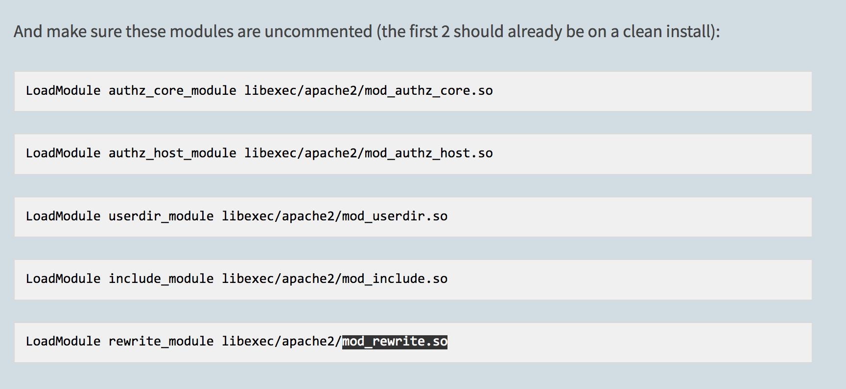

Therefore, it is critically important to enable the mode_rewirte.so so magento .htaccess and other set up can work correctly.

To enable it, go to the file /etc/apache2/httpd.conf

Uncomment the line LoadModule rewrite_module libexec/apache2/mod_rewrite.so

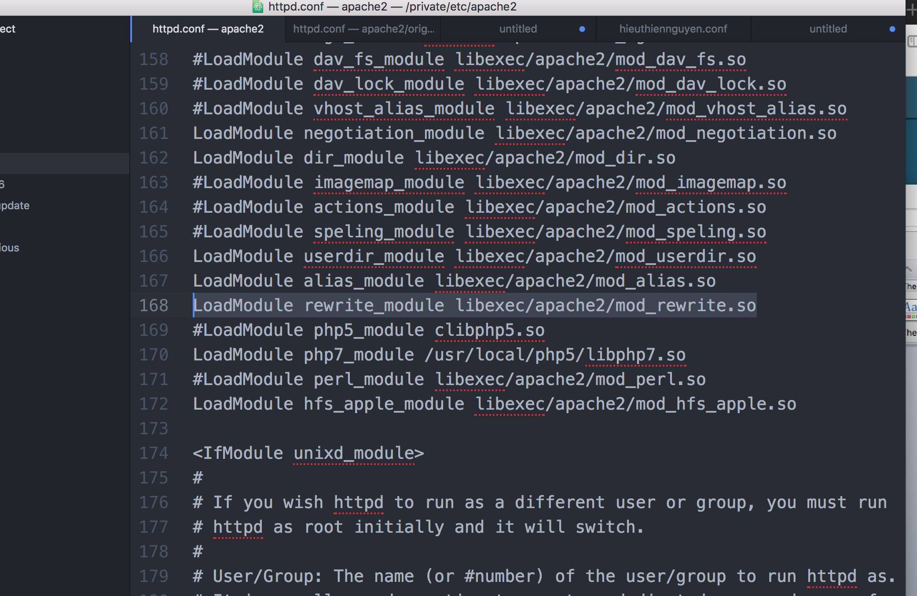

Since there are two options to put the document root in Mac

The default one is /Library/WebServer/Documents/

The user one is /etc/apache2/users/username.conf

However, Apache 2 version does not automatically enable the user one, therefore, we need to create a username.conf. In order for magento to work, making sure the permission is correctly setup.

2. Magento error after upgrade or install extension

<https://magento.stackexchange.com/questions/91838/error-after-magento-upgrade>

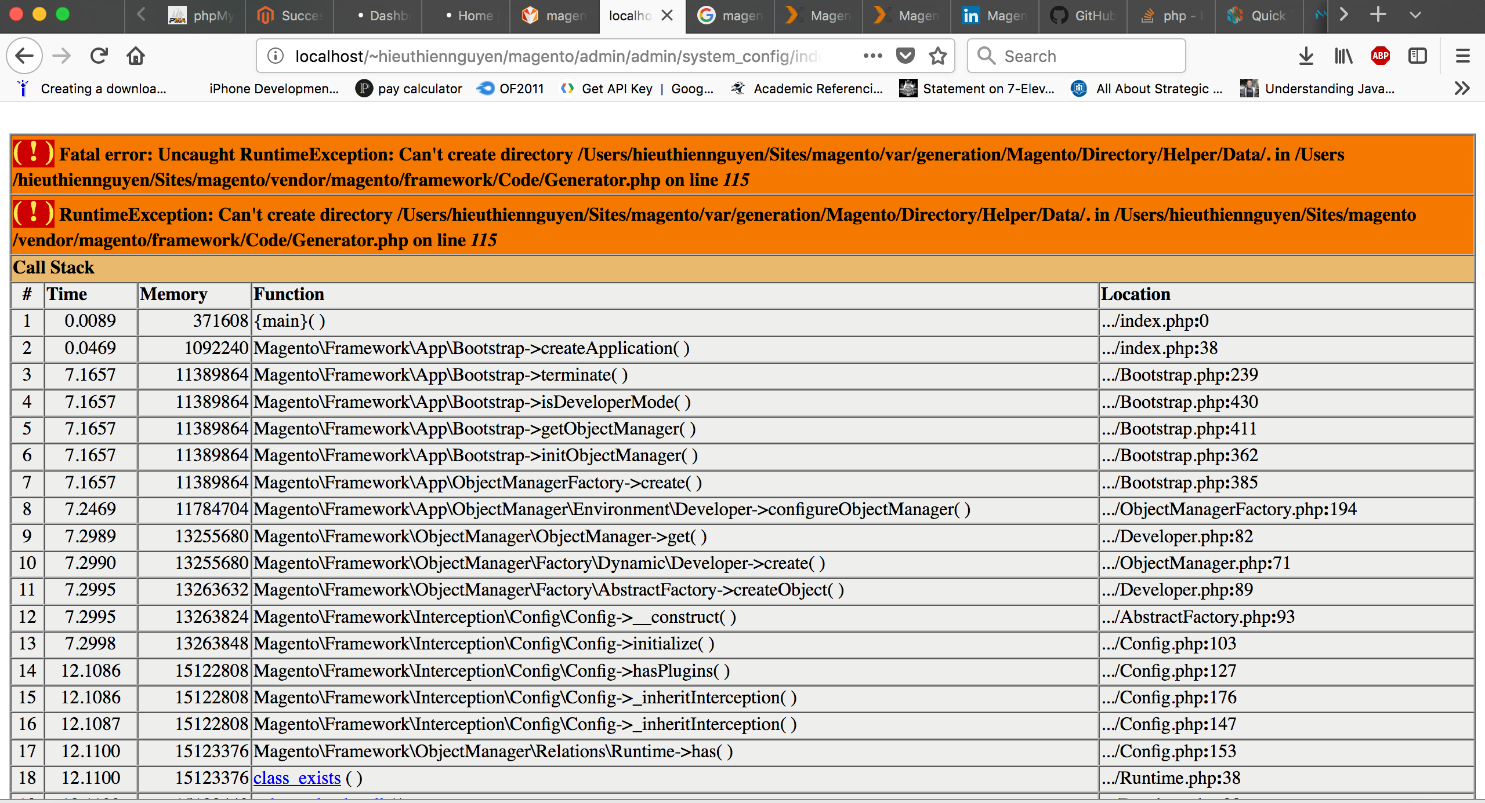

The problem occurs because the file permission or folder permission to set for read and write has change

Magento/var

Magento/pub

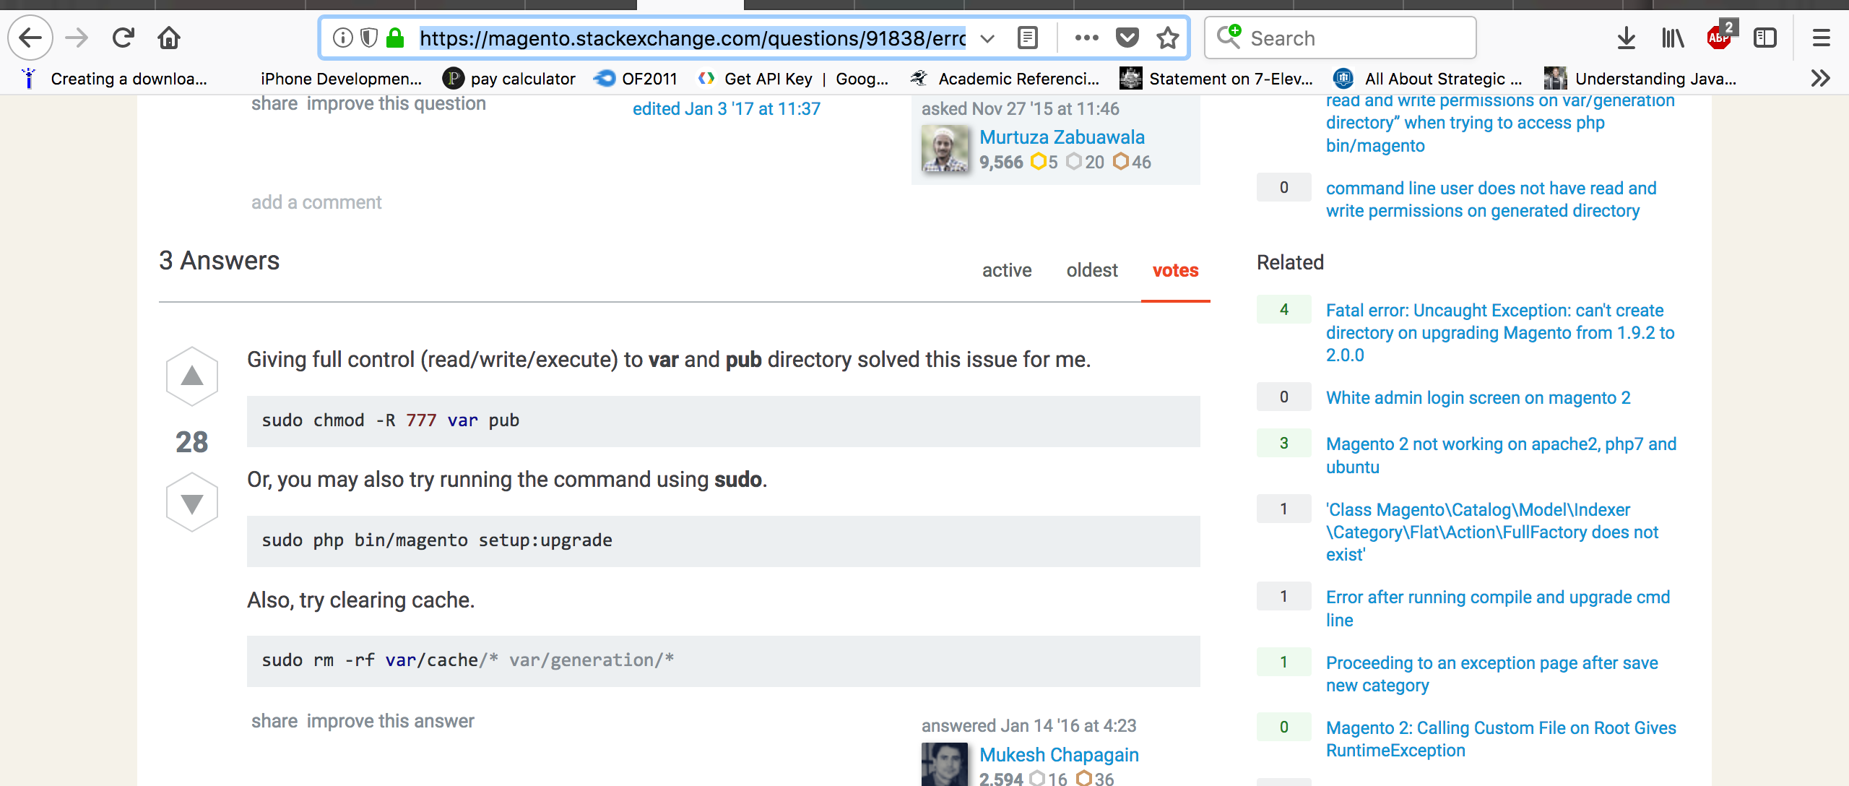

This is modified git content. Let see